Lesser　Panda

049100000, lesserpanda@mail.com, Sydney. NSW

**SUMMARY**

●Adapt well to new environments and always looking for new



challenges to ensure. Continually learning and growing.

●I always look for the positive in everything.

OBJECTIVE

I would like to obtain a part-time position as a server

**I’m available after 4:30pm on weekdays and all day on weekends.**

Utilizing my excellent communication skill.

WORK　EXPERIENCE

|  |  |  |
| --- | --- | --- |
|  | ●**2016 – 2022**  Nurse, Staff, Tokyo, Japan  -Find abnormal situation,  reacted sudden change  -Help their daily life and listened to their worries | ●2012 – 2016  Restaurant, Server, Tokyo, Japan  -Take orders from customers.  -Remove plates and cleaned tables.  -Handle a lot of customers at busy times. |

EDUCATION

-English language school upper intermediate

-Nursing, Lesser University – Tokyo, Japan, 2019

SKILLS

-NSW, RSA certificate, 2022

-Japanese: Native, English: Upper intermediate

-Japanese Nursing License

-International Driving License

VISA

-Working Holiday Visa – valid 1/4/2023

I look forward to the opportunity to discuss my qualifications in person at your earliest convenience. You can email me at **lesserpanda@mail.com** or call me by phone at **049100000**.

Thank you for your time, and I hope to hear from you soon.

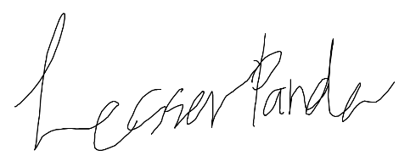Sincerely,

